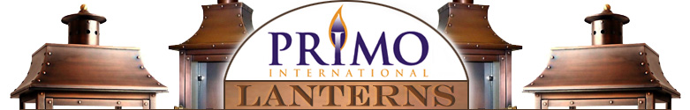

Your Electronic Ignition has been fully tested at our facility before being shipped to you. Upon receiving it, your installation requires minimal effort.

**Electronic components should be installed by licensed Electrician**

**Gas fittings should be installed by licensed Plumber**

At the bottom of the IGN box are three sets of wires. Blue, White and Green

Connect the Blue wire to the Black wire coming from out from the backtube

Connect the white wires to white wires

Connect the green wires to green wires

After these connections, you can have the licensed plumber install the bottom 90 degree fitting to secure the box to the bottom of the lantern, be careful not to pinch any wires with the copper IGN box.

In the backplate, connect the black to black, white to white and green to green

Your installation is complete

Please contact us at 225-296-6610 with any questions

Thank you